# 

**CSE523 : Machine Learning**

Winter 2021 - 2022

**Weekly Report - 5**

Dt : 09-03-2022

**Group Name : Discover Decipher**

**Group Members**

Nimisha Patel - AU1940146 - Btech Computer Science and Engineering.

Sakshi Shah - AU1940213 - Btech Computer Science and Engineering.

Astha Patel - AU1940312 - Btech Computer Science and Engineering.

Kareena Matwani - AU1940314 - Btech Computer Science and Engineering.

**Task Performed this week**

We implemented Feature Selection for regression for better implementation.

From the Feature selection, we were able to select the dependent feature on the response variable.

From the obtained results, different combinations of features were tried for linear as well as multi variable linear regression.

Implementing different combinations, the utmost accuracy obtained was 0.9 from feature Engine size, Fuel Consumption City, Fuel Consumption Hwy, Fuel consumption Comp (L/Km), Fuel consumption Comp (mpg) and Cylinders {Features} used to predict the numeric value of CO2 emission.

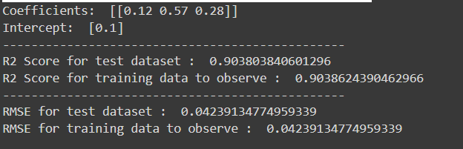

**Other combinations**

1. **Engine Size, Fuel consumption comb (mpg), cylinders**

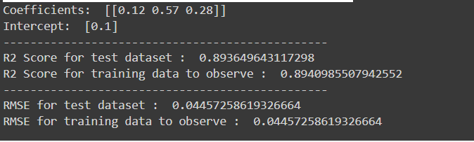

1. **Engine Size, Fuel consumption comb (L/Km) , cylinders**

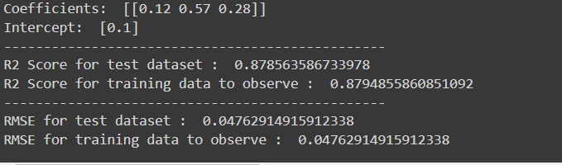

1. **Fuel Consumption City (L/100 km),Fuel Consumption Hwy (L/100 km), Fuel Consumption Comb (L/100 km)**

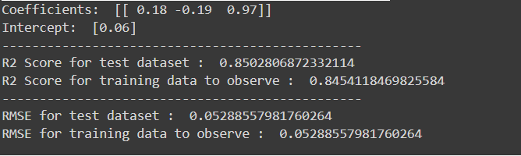

**Task to be Performed next week**

* Polynomial Regression
* Classification based prediction